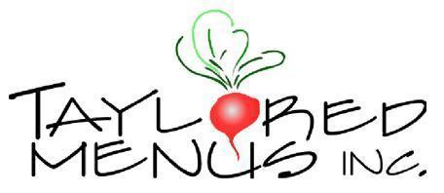

2023 Hanukkah Menu - Thursday 12/7 – Thursday 12/14
Phone (914) 741-5410 Web order: www.tayloredmenus.com
Pickups at our Café location — 101 Castleton Street building – off of Marble Ave. Pleasantville, NY.
NO SPECIAL ORDERS PLEASE
PLEASE READ BELOW FOR PICKUP SCHEDULE & ADDITIONAL INFORMATION

APPETIZERS (each tray feeds 8-10 people)

Potato latkes (24 minis to a tray) $26 per tray
Mashed sweet potato latkes (24 minis to a tray) $25 per tray
Zucchini potato latkes (24 minis to a tray) $27 per tray
Gluten free potato latkes (24 minis to a tray) $27 per tray
8 oz - applesauce $ 4 each
8 oz sour cream $ 5 each
Matzo ball soup – serves 2-3 $14/ quart
House made hummus (16 oz) & pita chips (Serves 8 ish) $27
Pigs ‘n blanket (12 per tray) $13 per tray
Round Challah & round challah w/ raisins (PLEASE SPECIFY) $10 each

MAIN COURSE
Braised 1st cut Brisket -sliced w/ our caramelized onion gravy $27 per lb.
Extra brisket gravy $10 pint
Whole herb & lemon roasted chicken cut into 8’s $18 each
Potato crusted salmon (8 pieces) $51 per tray
½ tray 4 pieces $33 per tray

SIDE DISHES (each tray feeds 8-10 people)
Roasted Yukon gold potatoes - Mediterranean herbs $24
Roasted Brussels sprouts $27
Pearl couscous w/ roasted eggplant, feta & garbanzo beans $24
Mixed greens salad with chopped veggies & a maple balsamic vinaigrette $22

Please allow 48-hour notice on orders. Orders for the first night must be placed by Sun. Dec. 3rd at 4pm.
DELIVERIES: $15 Within a 5-mile radius, $25 outside the 5 mile radius

Our pickup schedule is as followed:
Thursday 12/7 11 am-6:30 pm , Friday 12/8 11 am till 6 pm Saturday 12/9 9 am till 1 pm.
Sunday 12/10, Monday 12/11 pick up NOT AVAILABLE
Tuesday 12-12 through Thursday 12/14 11 am till 6:30 pm

Please inquire on staffing & delivery available. Both will be allocated on a first-come-first-serve basis. We will be serving certain items on our Weekly Menu for smaller portions.

FOOD ALLERGIES? If you have a food allergy, please speak to the owner, manager, chef, or your server.

