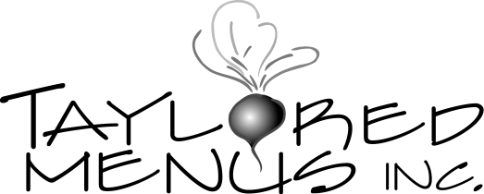

101 Castleton Street Suite 103 Pleasantville, NY 10570
French Inspired — Bridal Shower

Stationary Appetizers
Cheeseboard—Chevre log w/ berries & grapes- flatbreads & water crackers
Fresh vegetables crudites w/ hummus

Buffet
-Assorted Tea Sandwiches: (Choose 4)
-Smoked Salmon, scallion cream cheese & capers on Pumpernickel Bread
-Open face cucumber, mint & cream cheese on black bread squares
-Tuna salad w/ craisins & apples on mini brioche
-Turkey, brie & cranberry on mini croissant
-Goat cheese & watercress on cinnamon-raisin bread triangles
-Thinly Sliced Roast Beef w/horseradish cream and radicchio on mini croissant
-Radish, arugula & butter on mini brioche

-Assorted grilled vegetable platter
-Fig and Pear Mixed Green Salad w/shaved parmesan cheese and maple balsamic vinaigrette. Sour dough croutons on the side

Dessert
Biscotti
Mini cheesecake bites
-Jean Jacques assorted macaroons
Chocolate chip cannoli
-Coffee & tea set up

PRICE PER HEAD: $39.95 per person

STAFF: Chef @ $50 per hr.
Based on XX guests Servers @ $35 per hr.
Bartenders @ $40 per hr.
+

RENTALS: Your menu may have rental needs.
Such as: coffee urn, serving utensils, linens, platters, dishes, glasses, cutlery, etc. We suggest Cartwright Party Rentals @ 914-241-7888. Taylored Menus will coordinate all rental needs.

BEVERAGES: Taylored Menus can supply all non alcoholic beverages to include: House made ice tea & lemonade, assorted sodas, sparkling water, all mixers, all juices & all bar fruit garnishes + ice ADD$7.75 per person
+
DISPOSABLES: Taylored Menus can supply:
Clear plastic plates in 2 sizes, all silver plastic cutlery, clear plastic
cold cups, white coffee cups & 2 sizes white paper napkins. Additional $4.50 per person.

OR
Upscale compostable bamboo /
palm leaf disposable available
for– Add $5.50 per head.

GRATUITY: Host to tip staff directly

DEPOSIT: Pending menu / quote approval

HEALTHY REGARDS,

M. Taylor Smelser

Executive Chef / Owner
Taylored Menus Inc.
(914) 741-5410
taylor@tayloredmenus.com
www.tayloredmenus.com

